Praveen kanumarlapudi

Weather Data Analysis Architechture

For dew point temperature

Table of Contents

Overview 3

Access and Credentials : 3

Resources used: 3

High level Architecture 4

Architecture flow: 5

Thought Process: 5

Sample code: 6

Bootstarp script: 6

Pyspark submit for EMR: 6

Pyspark: 6

Screen shots: 8

Athena: 8

Quick sight: 8

# Overview

This document provides architecture of a highly available weather data analysis system which has the capability to ingest unstructured netCDF data and converting data to a structured tabular format in near-real time using different services available in AWS.

**<Please note: I had to delete the sns subscription which is the first component of this architecture since it was triggering whole flow and I got a bill of $50 for one day. since there is no direct way to disable it I had to delete it.>**

# Access and Credentials :

User Name**:** bigdata_user

Password**:** Bigdata123!

Console**:** https://pk-aws.signin.aws.amazon.com/console

Region**:** N.Virginia and

London (for SNS Subscription)

# Resources used:

* **S3 bucket:** pk-big-data-assessment
* **SNS Subscription:** arn:aws:sns:eu-west-2:021908831235:aws-earth-mo-atmospheric-mogreps-uk-prd 🡪 Region – **London for SNS Subscription**
* **Lambda Functions:** arn:aws:lambda:us-east-1:775703772184:function:sns-lambda-trigger

arn:aws:lambda:us-east-1:775703772184:function:Trigger_Datapipeline

* **Data pipeline:** df-03259663RH3QYEGZB2YJ region us-east-**1**
* **EMR**: will triggered from data pipeline
* **Glue Crawler**: weather_data_crawler
* **Glue Catalog Table:** cubeflatten_cube
* **Athena –** To query transformed data
* **Quick Sight – cubeflatten_cube Analysis**

# High level Architecture



1. SNS Subscribed to topic arn:aws:sns:eu-west-2:021908831235:aws-earth-mo-atmospheric-mogreps-uk-prd
2. Lambda arn:aws:lambda:us-east-1:775703772184:function:sns-lambda-trigger

will be triggered when event in SNS topic occurs which parses the JSON event and extracts bucket and object information and forms input and output uri’s

1. Lambda arn:aws:lambda:us-east-1:775703772184:function:Trigger_Datapipeline with the information from previous lambda triggers the Data Pipeline **asynchronously** with a EMR activity.
2. A pre-configured data pipeline with EMR activity is triggered also with SNS event post (for any of future needs)
3. EMR Cluster with Bootstrap for environment setting and a Pyspark script to flatten the cube data will be launched on a Private subnet which has a VPC End-point configuration with S3. **s3:// pk-big-data-assessment** holds configs, shell scripts, result from Pyspark script.

**Details:**

Data Pipeline: df-03259663RH3QYEGZB2YJ

S3: **s3:// pk-big-data-assessment/config/**

**s3:// pk-big-data-assessment/python/**

**s3:// pk-big-data-assessment/flatten_cube/<date>/**

**s3:// pk-big-data-assessment/spark-conf/**

1. results from Pyspark script will be stored in **s3:// pk-big-data-assessment/flatten_cube/<date>/** in parquet format, it iscrawled by glue crawler and creates table cubeflatten_cube in Glue catalog
2. Quick sight dashboards are created on the data in catalog
3. Athena is also used to query the data from Glue catalog.

# Architecture flow:

A new event in SNS topic triggers lambda function sns-lambda-trigger (N. Virginia), this lambda has two responsibilities

* + copies data from source bucket to pk-big-data-assessment bucket
  + triggers second lambda ‘Trigger_Datapipeline’

reason to copy data from source to local bucket is I have enabled VPC to use ‘VPC End point’ so the EMR services can use pk-big-data-assessment securely with Amazon’s network.

The second lambda function triggers a pre-defined on-demand data pipeline **df-03259663RH3QYEGZB2YJ**, which is customized to launch EMR activity with custom **conda env for iris** in EMR which would be utilized by Pyspark. Bootstrap is available at

s3:// pk-big-data-assessment/config/ emr_conda_setup.sh and Pyspark at

s3:// pk-big-data-assessment/python/ iris_cube_analysis.py

*(Please see emr_conda_setup.sh and iris_cube_analysis.py at code section of this document)*

I have considered to extract only ***dew_point_temperature*** variable, if a input nc file doesn’t have this variable Pyspark will throw exceptions which looks like

raise iris.exceptions.ConstraintMismatchError('no cubes found')

iris.exceptions.ConstraintMismatchError: no cubes found

Once EMR completes the job it writes results back to s3:// pk-big-data-assessment/flatten_cube/<date>/ this location is crawled by glue crawler and create a table *cubeflatten_cube* in glue catalog

cubeflatten_cube is accessed by both quick sight and Athena, athena results were written back to encrypted s3 bucket.

# Thought Process:

End goal of the is architecture is to help build a simple yet highly-available, fault tolerant secured application. I have considered to use aws managed and serverless services whenever possible because of their default characteristics of high availability, no maintenance overheads, and they are monitored and protected by **AWS global network security.**

**cost effectiveness:** I have used **lambda, data pipeline, Athena, Glue, Quick Sight** these were paid for what we have utilized no upfront for hardware or software required. Also, there is no need to guess capacity since all these services are highly available. **EMR** service I have used for running spark script **auto terminates** when the step completes and releases the master and worker nodes once task completes, Also I have used instances with right balance between On-demand and Spot instances so that application will be both efficient and cost effective.

**Highly Available:** I wanted thearchitecture to be highly available with ‘zero’ down time, so I have carefully implemented the architecture so it could be elastic and can scale out and scale in automatically based on the load, **no extra effort or precautions needed to handle huge data**, All managed services are **highly available** and **EMR has auto scaling** enabled it has the capability to scale up and down the nodes based on the amount of data it is dealing with.

**Security:**

* All the services used here were assigned with **minimum permissions** required for the job to complete.
* The S3 bucket I am using for this whole architecture is encrypted at rest using **S3-SSE**
* All the resources launched by EMR are launched in a **private subnet** with access to internet to download conda packages were enabled by a **NAT**,
* **VPC endpoint** is enabled between S3 bucket and VPC to make sure the communication between S3 and ec2 instances launched by EMR service are using private aws network not public internet for operations
* I have used Amazon managed services for of the cases because these are monitored and protected by **AWS global network security** which gives additional layer of protection

# Sample code:

## Bootstarp script:

|  |
| --- |
| #!/bin/bash  set -e  wget https://repo.anaconda.com/archive/Anaconda3-2019.10-Linux-x86_64.sh  bash Anaconda3-2019.10-Linux-x86_64.sh -b -p /mnt1/anaconda3  export PATH=/mnt1/anaconda3/bin:$PATH  echo "export PATH="/mnt1/anaconda3/bin:$PATH"" >> ~/.bash_profile  echo "export PYSPARK_PYTHON="/mnt1/anaconda3/bin/python3"" >> ~/.bash_profile  conda install -y -c conda-forge iris  conda install -y -c anaconda boto3  aws s3 cp $1 /mnt1/ --region us-east-1 |

## Pyspark submit for EMR:

|  |
| --- |
| command-runner.jar,spark-submit,--deploy-mode,client,--master,yarn,--conf,spark.yarn.appMasterEnv.PYSPARK_PYTHON=/mnt1/anaconda3/bin/python,--conf,spark.executorEnv.PYSPARK_PYTHON=/mnt1/anaconda3/bin/python,--conf,spark.pyspark.python=/mnt1/anaconda3/bin/python,--num-executors,64,--conf,spark.executor.memory=4g,#{my_python_script},#{my_s3_input},#{my_s3_out} |

## Pyspark:

|  |
| --- |
| from __future__ import print_function  import sys  import iris  import datetime  import logging  import boto3  import os  from operator import add  from pyspark import SparkContext  from pyspark.sql import SparkSession  from pyspark.sql import Row  from pyspark.sql.types import *  def extract_dew_point(fname):  # cube_1 = iris.load(fname,'dew_point_temperature') -- returns cubeList  try:  dew_cube = iris.load_cube(fname,'dew_point_temperature')  return [mini_cube for mini_cube in (dew_cube.slices(['grid_longitude']))]  except:  logging.error('Did not find dew_point_temperature variable in Cube aborting ....')  def process_slice(cube_slice):  return [mini_cube for mini_cube in (cube_slice.slices([]))]  def scalar_extract(scalar_cube):  result=[]  for i in range(len(scalar_cube)):  time = scalar_cube[i].coords('time')[0]  time_str = str(time.units.num2date(time.points[0]))  lat = scalar_cube[i].coord('grid_latitude')[0].points[0].tolist()  lon = scalar_cube[i].coord('grid_longitude')[0].points[0].tolist()  realization = scalar_cube[i].coord('realization').points[0].tolist()  forecast_period = scalar_cube[i].coord('forecast_period').points[0].tolist()  forecast_reference_time = scalar_cube[i].coord('forecast_reference_time')  forecast_reference_time_str = str(forecast_reference_time.units.num2date(forecast_reference_time.points[0]))  result.append(Row(time_str, lat, lon, realization, forecast_period, forecast_reference_time_str))  return result  def copy_to_local(s3_in, local_dir):  s3 = boto3.client('s3')  s3.download_file(s3_in.split("/")[2], s3_in.split("/")[3], local_dir+ 'copiedFromS3.nc')  logging.info('Copying '+s3_in.split("/")[2]+'/'+s3_in.split("/")[3]+'to local'+local_dir+ 'copiedFromS3.nc')  logging.info('list dir' +str(os.listdir(local_dir)))  return local_dir+ 'copiedFromS3.nc'    if __name__ == "__main__":  if len(sys.argv) < 2:  print("Usage: s3://<nc_file> s3://<output> objectname", file=sys.stderr)  sys.exit(-1)    local_dir = '/mnt1/'  sc =SparkContext()  spark = SparkSession\  .builder\  .appName("Weather data analysis")\  .getOrCreate()  dew_temp_schema = StructType(\  [StructField('recorded_time', StringType()),\  StructField('grid_latitude',FloatType()),\  StructField('grid_longitude',FloatType()),\  StructField('realization',IntegerType()),\  StructField('forecast_period',FloatType()),\  StructField('forecast_reference_time_str',StringType())]\  )    #:local_file = copy_to_local(sys.argv[1], local_dir)  dew_point_temp_rdd = sc.parallelize(extract_dew_point('/mnt1/'+sys.argv[1].split("/")[3]), 128)  flatten_cubes = dew_point_temp_rdd.map(lambda cube_slice: process_slice(cube_slice)).flatMap(lambda mini_cubes:scalar_extract(mini_cubes))  dew_temp_data_df = spark.createDataFrame(flatten_cubes, dew_temp_schema)  dew_temp_data_df.write.parquet(sys.argv[2])  spark.stop() |

# Screen shots:

# Athena:

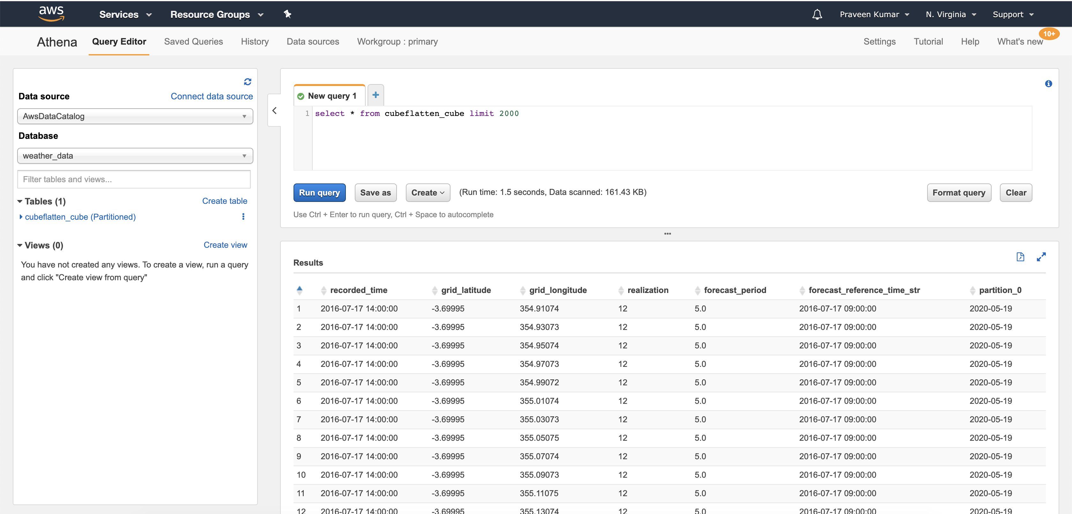

## Quick sight:

